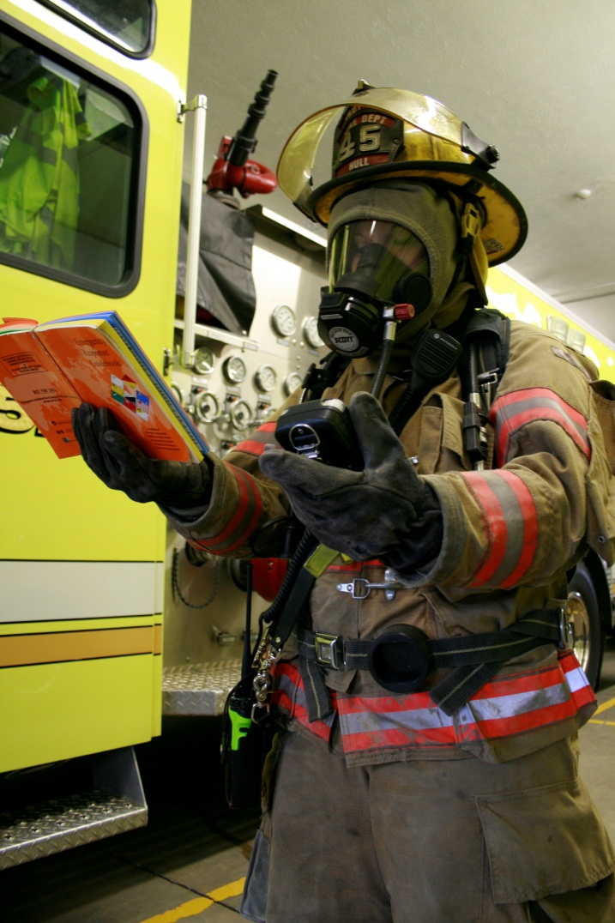
PRIMMER on calibration and bump testing:
James R. MacNeal
Pangaea Gases, LLC
April 24, 2012

Calibration
Calibration is the process of verifying that an analytical instrument's response is accurate by exposing the sensor to a known concentration of the gas of interest, comparing the readout of the instrument to the concentration stated on the calibration gas cylinder label, and adjusting the instrument's readout so the indicated concentration coincides with the concentration stated on the calibration gas cylinder label. Some instruments do this process automatically (take nominal label product) and some require that the operator adjusts the read out manual to match the read out to the concentrations shown on the cylinder label (takes a certified grade of product; NIST traceable is also available for pharma and other customers who need the traceability). A true calibration requires that the calibration gas is routed to the sensor such that there is no entrained air to dilute the calibration gas as it contacts the sensor. A regulator and flowmeter are used to perform a true calibration.

Bump Testing
Bump testing is simply exposing the sensor of an already calibrated instrument, to a shot of gas from a calibration gas cylinder or frequently, aerosol canister which contains a precise concentration of the gas of interest. The objective is simply to verify that the sensor is responsive to the gas of interest at the time the instrument is to be used. A properly calibrated instrument may have been dropped or had a cell go bad between the last calibration and the time of actual use. Bump testing simply verifies that the instrument is still responsive to the gas of interest. It is not a calibration, as there is no way to accurately measure the concentrations of gas sprayed on the sensor from the bump test gas aerosol canister, which is not a true cylinder, but a simple spray can with a spray nozzle; no regulator or flowmeter is used. Lots of ambient air gets mixed in with the spray shot form the canister as it impacts the sensor. Therefore there is no need to have a certified gas for bump testing unless the customer absolutely requires it. Comment:
It is an excellent safety practice to bump test any instrument, even if recently calibrated, prior to use where the readout data will be used to make decisions about the safety of the air being tested. Without the bump test it is impossible to verify and know that the instrument is providing reliable data. For example, an instrument which has been recently calibrated may have had a sensor go bad since the calibration was performed. That instrument might be used to acquire data on the level of contamination of an atmosphere which personnel may enter. If no bump test was performed, there is no way to know that the sensor is responding to the gas of interest. Bad data could be acquired and could prompt a bad decision regarding the safety of personnel entering that atmosphere, which could lead to injury and even death.

Sensor Challenge:
Literally every instrument should be challenged before each actual use, unless it has been calibrated moments before the actual use. All that is necessary to do is to direct a stream of gas from the cal gas regulator/flowmeter onto the sensor and verify that the instrument sensed the gas of interest. It cannot be quantitated because of the air that also is entrained in the bump test gas stream. Users can also use a small aerosol canister with the cal gas in it so they can just use the spray nozzle to direct a stream of gas onto the sensor. Concentrations of gases used or sensor challenge should be sufficiently high that they cause the alarms to sound for each gas in the gas mix for which a sensor is installed in the instrument.
Sensor challenge accomplishes is a critical safety improvement for the users, who now have confidence that their instrument is capable of sensing the gases of interest, and that the alarms are functioning.

